Deadlocks

Deadlocking is when a process prevents another process from accessing resources.
- Two trains and one track
- Set of processes blocked due to one resource hogging the process
Deadlock is a situation where a set of processes are blocked because each process is holding a resource and waiting for another resource acquired by some other process.

Four Conditions for Deadlock
1. Mutual exclusion - each resource assigned to 1 process (a)
2. Hold and wait - process holding resources (b)
3. No preemption – resources cannot be taken away
4. Circular wait – process C is waiting for resource U, (Deadlock)
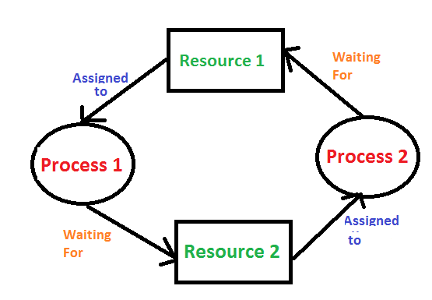
(a) resource R assigned to process A
(b) process B is requesting/waiting for resource S
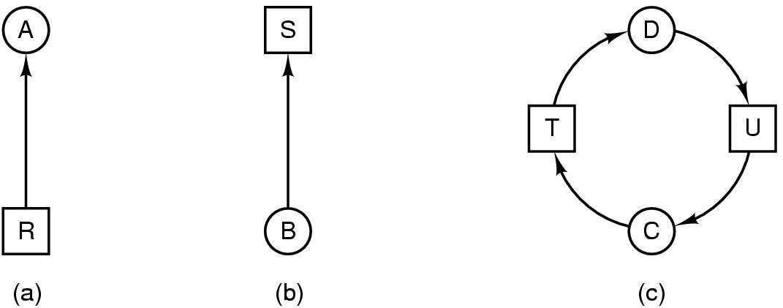
(c) process C and D are in deadlock over resources T and U

Banker’s Algorithm
The banker’s algorithm is a resource allocation and deadlock avoidance algorithm that tests for safety
n = processes
m = resource types
Available
- 1-d array of size m (number of resources)
Allocation
- 2-d array of size n x m (resources currently allocated)
Max Need
- 2-d array of size n x m (remaining resources needed for each process)
- can also be calculated by (Need[] = Max[] - Allocation[])

